Problem 01: Write a Java program to print the sum (addition), multiply, subtract, divide and

Remainder of two numbers.

Solution 01:

Source Code Window:

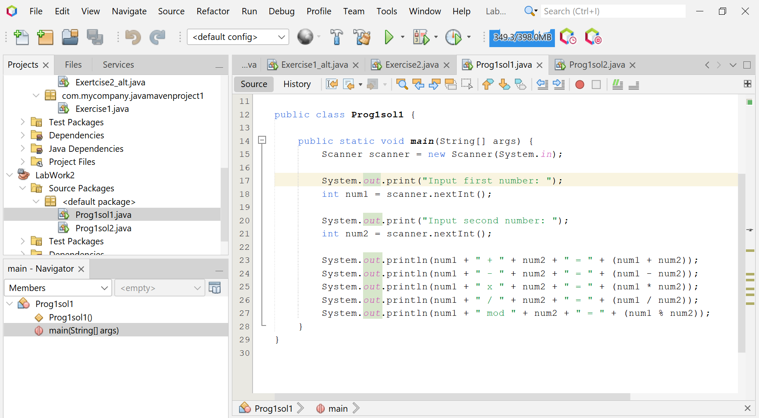

Output Window:

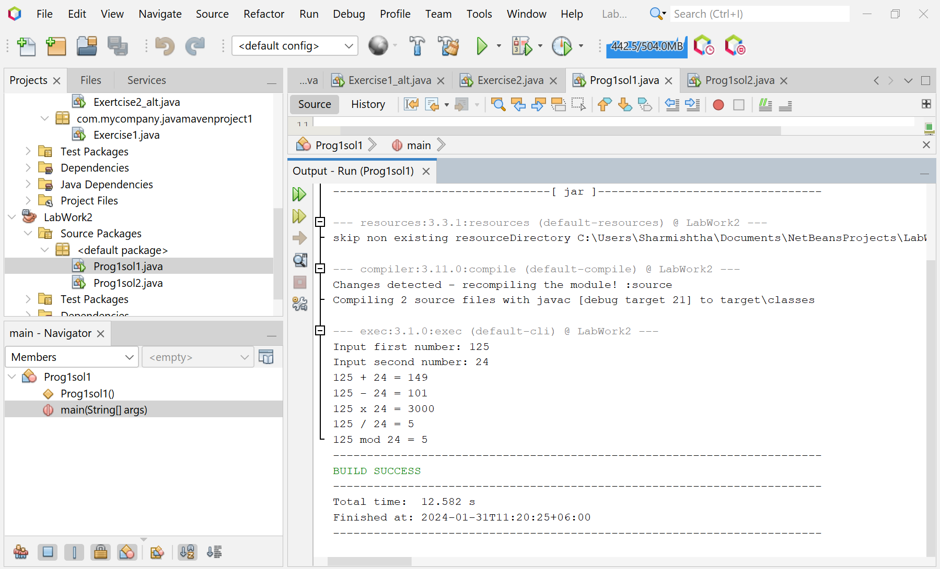

Solution 02:

Source Code Window:

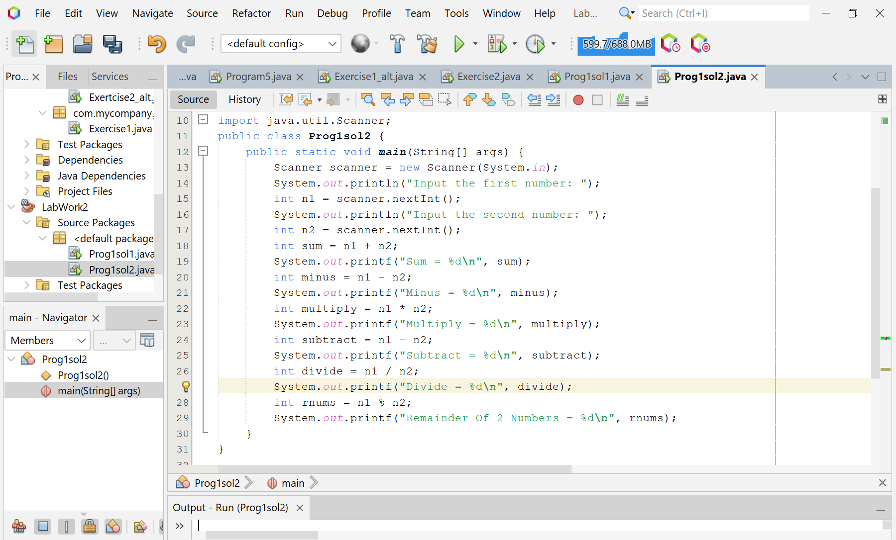

Output Window:

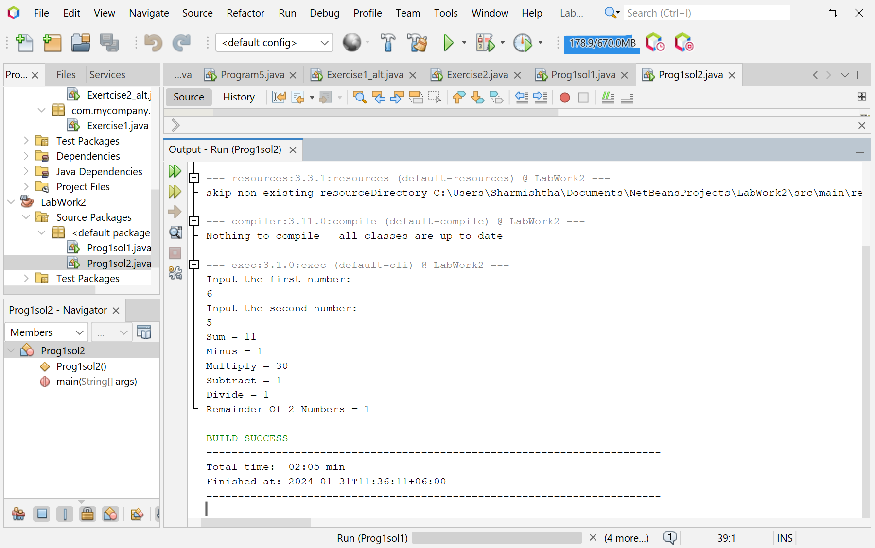

Problem 02: Write a Java program that takes a number as input and prints its

multiplication table up to 10.

Source Code Window:

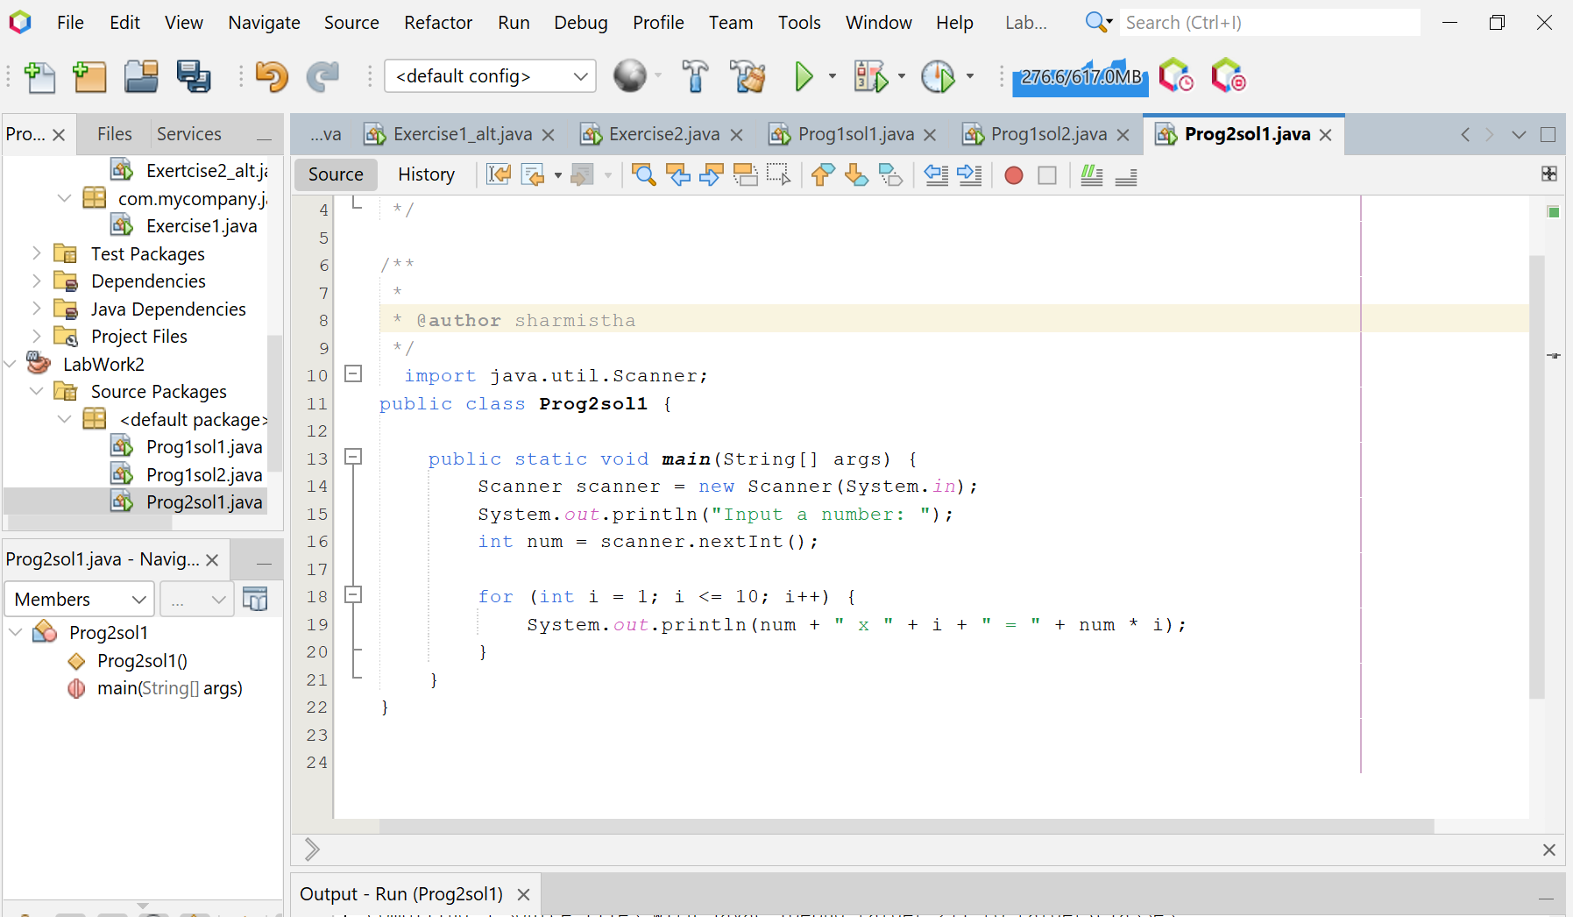

Output Window:

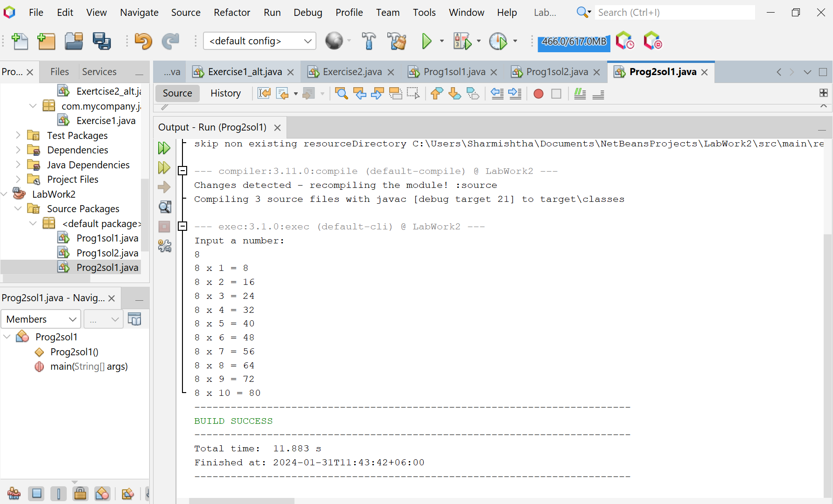

Solution 02:

Source Code Window:

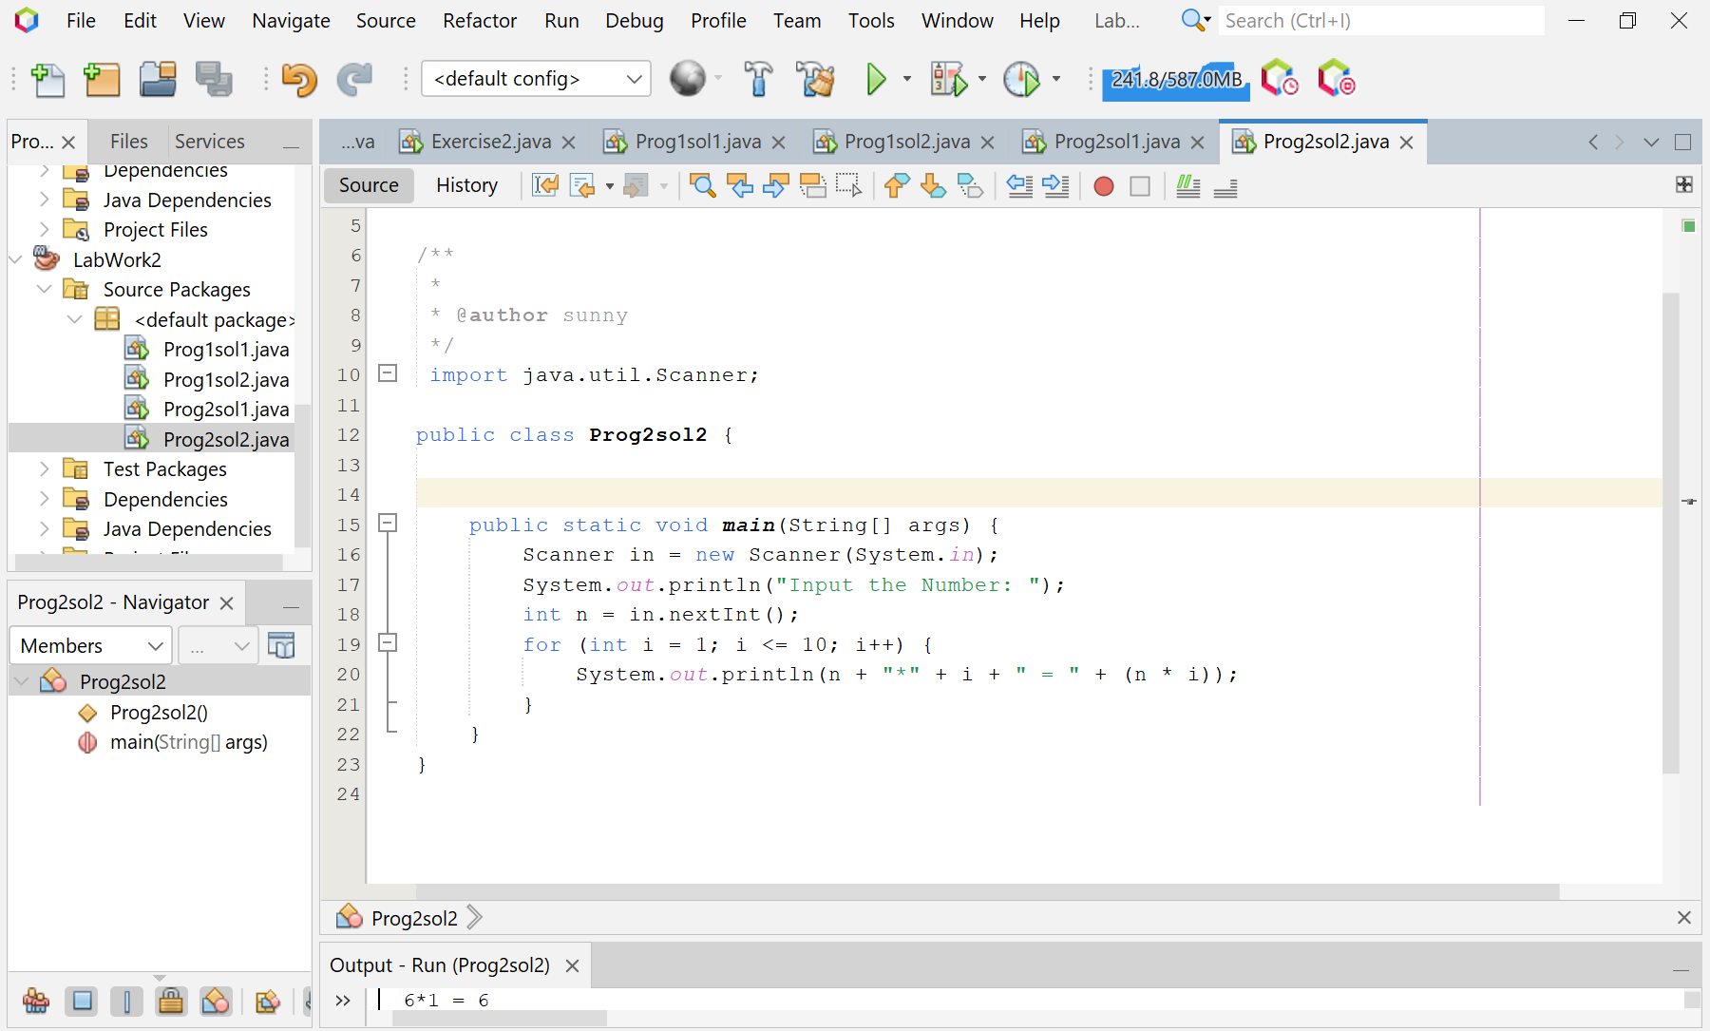

Output Window:

